**Title**: Sun Cycle

**Theme**: Exergaming, health, VR, Open-World Exploration, Competition, Sports and Racing

**Catchphrase**: Ride, Race, and Conquer Reality in Sun Cycle: Where Your Pedals Power Your Adventure

**Platform aspects:**

SteamVR:

"Sun Cycle" could be developed for PC gaming platforms, and it could utilize SteamVR as the technology framework to enable virtual reality gameplay. This means that players who own compatible VR headsets and use the Steam platform could access and play "Sun Cycle" through the SteamVR platform. SteamVR provides tools and APIs that developers can use to create VR experiences, making it a suitable choice for a VR game like "Sun Cycle."

PlayStation (PS4, PS5):  
Developing "Sun Cycle" for PlayStation consoles (PS4 and PS5) can capitalize on the platform's extensive player base, spanning casual gamers to enthusiasts, and its well-established VR support through PlayStation VR. With millions of users and the potential for diverse demographics, the game can attract a broad audience. Additionally, considering exclusive opportunities and timed exclusivity deals, the PlayStation ecosystem offers a pathway to heightened visibility, potential sales, and an entry point into the VR gaming market.  
  
Xbox (Xbox One, Xbox Series X/S):  
Targeting Xbox platforms, such as Xbox One and Xbox Series X/S, for "Sun Cycle" offers the chance to tap into the Game Pass phenomenon, leveraging the subscription service's popularity to increase the game's exposure. The backward compatibility of the Xbox Series X/S ensures that the latest hardware can enjoy "Sun Cycle" while accommodating players on older Xbox One consoles. Although Xbox currently lacks a dedicated VR headset, the potential for Microsoft's future VR and AR plans could open doors for "Sun Cycle" to explore the virtual reality landscape.

**Single Paragraph:**

Embark on an immersive journey of adventure and fitness in 'Sun Cycle.' Pedal your way through an expansive VR world, where your stationary cycling powers the action. Engage in thrilling races across diverse landscapes, embrace the challenge of delivery quests in a free roam map, and collect valuable data using integrated sensors. With the power of VR, 'Sun Cycle' invites players of all backgrounds to experience the fusion of gaming and exercise, while the potential for console platforms like PlayStation and Xbox ensures a broad reach, promising a new era of interactive and healthy entertainment.

**Core Pillar of gameplay:**

"Physical Engagement" as a core pillar of gameplay in "Sun Cycle" revolves around the active involvement of players' physical movements to control their in-game avatars and impact their performance. This gameplay is central to the game's concept of combining exercise with virtual reality gaming.

Players use their real bicycles, equipped with sensors, to simulate cycling within the virtual world. As players pedal on their stationary bikes, their movements are translated into in-game actions, allowing them to control the speed and direction of their avatars. Pedaling speed determines the avatar's movement speed in the virtual environment. Players can control the direction of their avatar by steering the handlebars of their real bicycle.

Just like in real cycling, players need to manage their energy levels. Pedaling faster consumes more energy, while slowing down conserve’s energy. This dynamic encourages players to strategize when to speed up and when to maintain a steady pace. Players can use their physical engagement to strategically navigate races. For example, they might pedal intensely during a sprint challenge and then ease up during downhill sections to recover energy.

The physical engagement element adds a layer of challenge to navigating obstacles within the virtual world. Players need to adjust their pedaling intensity and direction to avoid obstacles and hazards effectively. The more players engage physically, the more they can improve their fitness levels and in-game skills. Regular physical activity can result in better performance, faster completion times, and increased stamina. By intertwining physical movement with gameplay, "Sun Cycle" serves as a motivational tool for exercise. Players are encouraged to stay active while enjoying a virtual cycling experience.

Physical engagement aligns with the game's focus on promoting a healthier lifestyle. Players can experience cardiovascular exercise, improved stamina, and other health benefits while having fun. Physical engagement enhances the immersion by making players feel more connected to the virtual world. It also offers a unique way for players to interact with the game environment.

Different types of challenges, such as sprints, endurance races, and hill climbs, provide players with varied gameplay experiences that require adjusting their physical engagement strategies.

**Relationship between goals and rules:**

**Target market and audience:**

**Screenshots and reference art:**

RingFit Adventure is a good inspiration for art and the players actively working out while completing races. It uses   
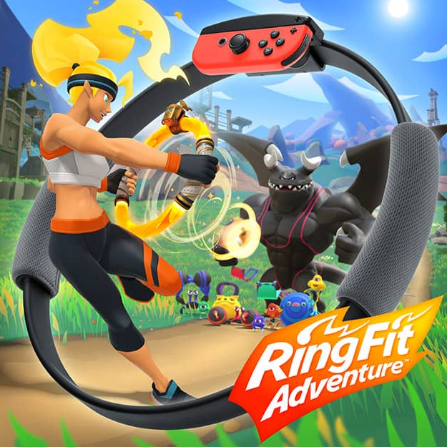

(RingFit Adventure, 2019)

Down Fast VR is another game where the player is required to complete a set for races.  
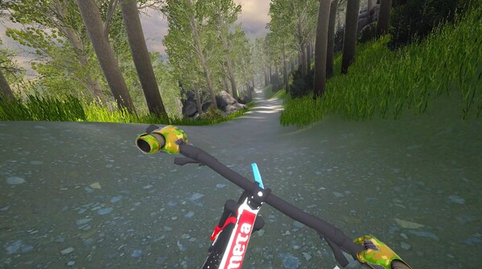

(Down Fast VR, 2022)

Sun Cycle will have the bicycle stationary just like VZFit  
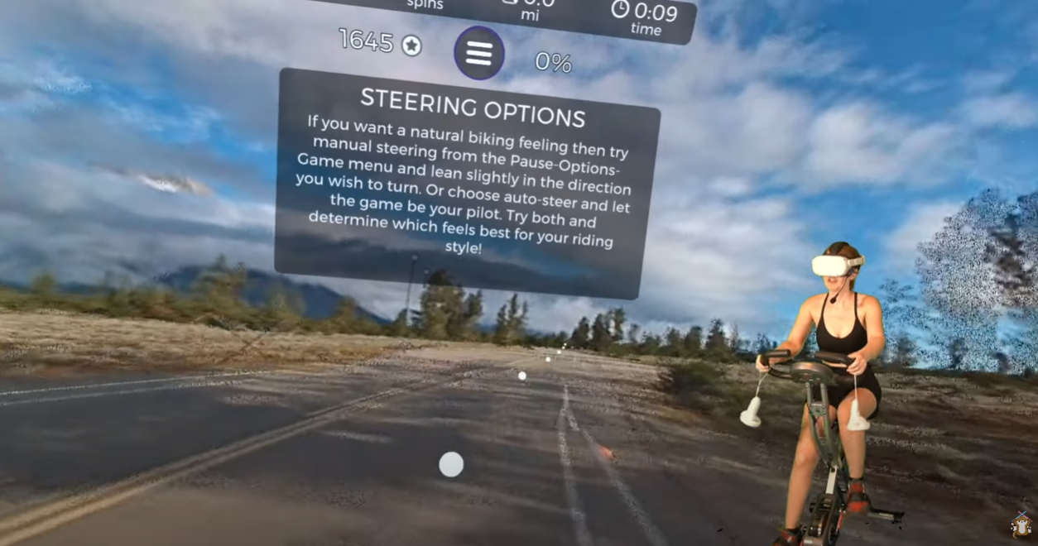

(OtterWordly screenshot, 2022)

**Bibliography**

<https://www.youtube.com/watch?v=7Nn9adpeo-M>  
<https://www.nintendo.com.au/games/nintendo-switch/ring-fit-adventure>  
<https://store.steampowered.com/app/1956860/Down_Fast_VR/>

**Appendices**

# **Rules**

## **Defining your game**

**What is the *victory* and *loss* conditions of your game?**

**Victory Conditions:**  
The primary victory condition in "Sun Cycle" is achieving personal goals and milestones within the game. Players aim to complete races and delivery quests, earning rewards and progressing through the game's content. Success is measured by reaching the finish line first in races or successfully completing delivery objectives. Additionally, players can track their accumulated data and achievements over time, such as distance travelled, calories burned, and quests completed, fostering a sense of accomplishment and improvement in their fitness journey.

**Loss Conditions:**  
While "Sun Cycle" is designed to promote a positive and engaging experience, there might not be traditional "loss" conditions in the game. Instead, the focus could be on encouraging players to stay motivated and continually improve their performance. If a player doesn't complete a race or quest successfully, they could have the opportunity to retry without significant penalties. The emphasis is more on progress and personal growth rather than outright failure. This approach aligns with the game's goal of providing an enjoyable and active experience.

**What are the *active* challenges of your game?**

**Time Trials**: Players compete against their own best times or against friends' times in time trial races. The challenge is to complete the race in the shortest time possible, motivating players to pedal harder and faster.  
**Endurance Races**: Endurance Races in "Sun Cycle" are exhilarating challenges that push players' physical limits and provide a platform for showcasing their dedication to fitness and their mastery of the virtual cycling world. These races are designed to simulate the experience of tackling lengthy cycling routes that require sustained effort and stamina.

The key to conquering endurance races lies in finding a balance between pacing oneself and maintaining a consistent level of effort throughout the race. Players need to gauge their energy reserves, strategically manage their pacing, and effectively utilize their virtual bike's capabilities to navigate terrain changes and potential obstacles. Uphill segments demand increased exertion, testing players' ability to power through resistance, while downhill stretches allow for recovery and speed boosts.

Successfully completing endurance races rewards players not only with in-game rewards such as virtual currency, gear upgrades, or cosmetic enhancements but also with a tangible sense of accomplishment. The recognition of their dedication and the progress they've made in their fitness journey is celebrated through virtual achievements and leaderboards that showcase their achievements to other players.

**Sprint Challenges**: Sprint Challenges within the captivating realm of "Sun Cycle" introduce exhilarating moments of intense pedal-to-the-metal action, designed not only to deliver bursts of heart-pounding excitement but also to enhance players' cardiovascular fitness in a dynamic and engaging manner. These challenges embody the essence of high-speed competition, demanding rapid and forceful pedalling as players navigate through specially designed virtual tracks that are perfect for unleashing their full cycling potential.

In a Sprint Challenge, the adrenaline rush is palpable as players accelerate their virtual bikes to breakneck speeds, their determination driving them to surpass their previous limits. These challenges encourage players to tap into their energy reserves and unleash explosive bursts of power, providing a workout that not only ignites cardiovascular activity but also intensifies the overall gaming experience.

As players engage in these rapid sprints, they encounter various terrain features that mimic real-world conditions—rolling hills, straightaways, and sharp turns—all meticulously crafted to demand precise control, strategic acceleration, and well-timed deceleration. The short yet intense nature of Sprint Challenges ensures that players maintain an elevated heart rate throughout, promoting endurance and stamina while simulating the intensity of real-world cycling sprints.

**Hill Climbs**: "Hill Climbs" in the world of "Sun Cycle" encapsulate the essence of conquering challenging terrains and mastering the art of uphill cycling. These virtual segments intricately recreate the arduous yet rewarding experience of climbing hills, pushing players to summon their inner strength and endurance as they navigate these steep inclines. Just like real-life hill climbs, these segments demand increased effort, determination, and strategic pedalling to overcome the resistance and reach the summit.

As players embark on Hill Climbs, they are transported to captivating virtual landscapes featuring gradients that mirror the complexities of real-world terrain. The challenge lies in the symbiotic relationship between the player's physical exertion and the virtual resistance encountered, providing an authentic sensation of cycling uphill. Pedalling harder against this resistance emulates the sensation of battling gravity and conquering the climb, adding a layer of realism to the gameplay.

Each Hill Climb introduces unique features that replicate the variability of outdoor cycling experiences. Some segments might present prolonged steady climbs, allowing players to find a sustainable rhythm, while others could feature alternating inclines and plateaus that require quick adjustments in pedalling intensity.

**Delivery Quests with Obstacles**: In the bright world of "Sun Cycle," "Delivery Quests with Obstacles" adds a dynamic layer of gameplay that gives players a thrilling, immersive experience that mixes the adrenaline of time-sensitive tasks with the art of precision. These adventures immerse players in a narrative where they take on the role of a dedicated courier charged with delivering essential supplies across various virtual environments while overcoming a variety of challenges that put their riding prowess and problem-solving abilities to the test.

As they begin these adventures, players face a range of difficulties, including topographical differences, environmental dangers, and strategic decision-making opportunities. As they pedal through crowded cities, peaceful country roads, and difficult off-road terrain, the time passes. In addition to getting there on schedule, the goal is to strike a careful balance between speed and accuracy because rushing could result in accidents and setbacks.

These objectives are completed to add to the overall sense of success that "Sun Cycle" delivers, encouraging an enjoyable gameplay experience that tests players' mental and physical abilities.

**Distance Challenges** The "Distance Challenges" in the "Sun Cycle" universe weave an engrossing tapestry of success and drive, inspiring players to set out on thrilling travels where each pedal stroke advances them. In order to feel a feeling of success and to increase their motivation to cover longer distances over time, these challenges provide players the ability to set their sights on achieving distance milestones during a single gameplay session.

Players are met by a variety of virtual settings that reflect the diversity and beauty of the real world as they embark on their bicycle odysseys. Each route offers a distinctive environment for players to immerse themselves in their riding experience, from wide open roads that reach into the distance to twisting routes that wind through gorgeous landscapes. The difficulty lies not only in crossing the distance, but also in keeping a steady rhythm and speed to enhance performance.

The mechanisms of the game painstakingly detect each pedal turn as you travel, converting physical effort into virtual advancement. As they pedal forwards, players can see their distance increase, giving them a visual reflection of their effort.

Beyond in-game wealth or aesthetic upgrades, distance challenge completion awards come in a variety of forms. While these incentives provide participants with concrete credit for their efforts, the main victory is the sense of accomplishment that comes from exceeding their distance objectives.

**Calories Burned Goals**: The "Sun Cycle" immersive world's "Calories Burned Goals" establish a meaningful link between virtual adventure and actual fitness goals, giving players a concrete and satisfying way to monitor their physical exertion. With the help of these challenges, players may set goals for how many calories they want to burn as they play, turning the act of virtual cycling into a routine workout that fits in well with their efforts to improve their health and wellbeing.

The pursuit of calories burnt turns into a driving force that directs players during games. The game's mechanisms convert players' physical output into calories expended as they pedal through picturesque routes, negotiate difficult terrain, and engage in a variety of virtual activities, enabling them to see the immediate results of their exertion in real time. Players are motivated to persevere by the excitement of seeing their development, which fosters a sense of empowerment and success.

**Virtual Competitions**: Within the engaging "Sun Cycle" universe, "Virtual Competitions" provide an electric gameplay dimension where people from all over the world come together in real-time races and challenges, developing a sense of community, friendship, and exhilarating competitiveness. Players can use this dynamic platform to demonstrate their abilities, compete amicably, and enjoy the thrill of global connectivity inside the virtual cycling world thanks to these events.

Virtual competitions offer rewards that go beyond the virtual world, such as the camaraderie of competing and interacting with other players as well as in-game achievements. Players are inspired to continuously improve their talents, pushing their physical and virtual performance to new heights, thanks to the immersive excitement of real-time competition and the validation of one's achievements.

**Interval Training**: The unique gameplay mechanic "Interval Training" introduces in the immersive setting of "Sun Cycle" incorporates dynamic cycling sessions that follow the principles of interval training, a well-known fitness method. With times of extreme effort interspersed with periods of active recuperation, these specialised programmes boost players' cardiovascular fitness and endurance while offering an enjoyable and transforming exercise experience.

Players go between quick sprints and more deliberate pedalling throughout these alternate stages, which are all intended to improve cardiovascular training. The virtual environments of "Sun Cycle" serve as the background for these phases. These sessions can have a range of lengths, from quick but intense intervals to longer cycles, providing flexibility for players with different fitness levels and objectives.

The benefits of interval training sessions go beyond the confines of the game, as participants leave with a greater sense of success as well as an improved cardiovascular capability. The interval strategy offers a dynamic integration of gaming and fitness, enabling players to see "Sun Cycle" as both a committed fitness companion and a source of pleasure.

**Progressive Challenges**: "Progressive Challenges" in the intriguing world of "Sun Cycle" present a dynamic and gratifying avenue for players to set off on a journey of growth, improvement, and ongoing achievement. These challenges are made to change as players' skill and fitness levels advance, generating a supportive environment and a constant sense of accomplishment throughout the gameplay experience.

Players that participate in Progressive Challenges are involved in a series of tasks that evolve and get harder over time. These tasks are thoughtfully designed to mirror players' developing skills, gradually providing more complicated environments, difficult opponents, and challenging goals. The goal is to engage on a journey of ongoing progress that mirrors athletes' actual journeys towards health, not only to overcome a single challenge.

Players are rewarded for completing each level of the challenge not just with in-game rewards and virtual upgrades but also with the knowledge that they are developing new talents and going beyond their comfort zones. This sense of accomplishment encourages them to continue playing the game and keeping up with their exercise routine, which starts a cycle of personal growth that extends beyond the virtual world.

**What is the *Internal Economy* of your game?**

|  |  |  |  |  |  |
| --- | --- | --- | --- | --- | --- |
| **Tangible resources** | **What value does it have?** | **How is it exchanged in the game?** | **Negative feedback mechanism (to avoid rapid growth)** | **Positive feedback mechanism (to avoid stalemate)** | **Random elements** |
| *Virtual Currency* | *A common component of game economies* | *Players can use this currency to purchase cosmetic upgrades for their virtual bikes, gear, and accessories, enhancing their in-game appearance.* | *The player will get less currency if they take too long to finish a course and if they crash on any object* | *Players will get extra currency when they finish the course quick and being flawless* | *None* |
| *Cosmetic Items* | *Self-Expression, Achievement Recognition, Goals and Motivation* | *Players can purchase cosmetic items using the virtual currency earned by participating in races, quests, and events* | *None* | *None* | *None* |
| *Quest Rewards* | *Enhanced Customization and Progression Incentive* | *Virtual Currency, Cosmetic Unlocks and Achievement Recognition* | *The same quest cannot give rewards if it is completed more than 1 time* | *Progressive Unlocks: Instead of delivering all rewards at once, the game could provide incremental rewards for completing certain milestones within a quest or race* | *None* |
| *Leaderboard Bonuses* | *For participating in Virtual Competitions or achieving high rankings in various challenges, players could earn leaderboard bonuses* | *virtual currency or unique customization options.* | *The player will get less rewards for not being high on the leaderboard once a month* | *Seasonal Resets, Tiered Rewards, Exclusive Rewards* | *None* |
| **Intangible resources** | **What value does it have?** | **How is it exchanged in the game?** | **Negative feedback mechanism (to avoid rapid growth)** | **Positive feedback mechanism (to avoid stalemate)** | **Random elements** |
| Experience and Skill | Performance Improvement, Challenge Mastery, Personal Growth | Time, Practice, Learning from Others | None | Skill-Based Leaderboards: Implement leaderboards that focus on different skill categories, such as fastest completion times or most accurate navigation. This allows players to compete with others who share their skill level. | None |
| *Strategic Thinking* | ***Competitive Advantage:*** *Strategic thinking gives players a competitive advantage by enabling them to plan their moves, anticipate challenges, and make informed decisions during races and challenges.* ***Problem Solving****: Strategic thinking allows players to analyse complex situations, identify optimal paths, and find creative solutions to overcome obstacles.* ***Adaptability****: The ability to adapt strategies in response to changing conditions* | ***Varied Terrain:*** *Races and challenges set in diverse terrains require players to employ different strategies.* ***Virtual Competitions****: Engaging in Virtual Competitions requires strategic planning to outmanoeuvre opponents.*  ***Leaderboard Strategies:*** *Players aiming for top leaderboard positions often need to devise strategic approaches to achieve the fastest completion times, highest accuracy, or other specific criteria.* | *None* | None | *None* |
| *Community and Relationships* | *Collaborative Learning, Friendly Competition, Social Interaction* | *In-Game Chat, Virtual Competitions, Leaderboards, Social Features, Forum or Community Hub* | *None* | *None* | *None* |
| *Sense of Accomplishment* | *Motivation, Emotional Reward, Personal Growth, Recognition* | *Achievement Unlocks, In-Game Badges, Leaderboard Rankings, Reward Systems* | *None* | *None* | *None* |
| *Player Identity* | ***Personal Connection:*** *Player identity allows individuals to project their personalities, preferences, and uniqueness onto their in-game avatars, creating a deeper personal connection with the virtual world.* ***Self-Expression:*** *The ability to customize avatars, bikes, and appearances enables players to express their creativity and individuality, fostering a sense of ownership and empowerment****. Recognition****: A distinct player identity, reflected through avatars and cosmetic items, can lead to recognition and social interactions within the game's community.* | ***Bike Customization:*** *Enable players to customize their virtual bikes with different paint jobs, decals, and accessories, allowing for personalization and self-expression.*  ***Cosmetic Items:*** *Offer a wide range of cosmetic items, such as clothing, helmets, and bike accessories, that players can exchange virtual currency for to enhance their avatar's appearance.*  ***Leaderboards****: Displaying avatars alongside leaderboard rankings allows players to associate their identities with their performance and accomplishments.* | *None* | *None* | *None* |

## **Describing the rules of your game?**

**Describe the rule of your game in further detail.**

### **Describe the operational rules of your game (Intrinsic relationship with constitutive rules)**

|  |  |  |  |  |
| --- | --- | --- | --- | --- |
| **Name** | **Description** | **Global or local rule** | **Impacts on…** | **Relates to constitutive…** |
| *Puzzles* | Each area has their own unique puzzle which vary in difficulty and complexity. Same puzzles could appear with different combination to solve them. | *Local* | Player progression and storytelling. | *Puzzle type* |
| Enemies | Some areas will  have different  types of  enemies to  increase the  difficulty of the  game and offer  some variety. Same monster could appear from previous stages. | Global | Current area player is in. | Enemy type |
| Interactive Objects | Each area will have objects the player can interact with such as ladders, crates, and levers. | Global | Current area player is in. | Object type |

### **Describe the constitutive rules of your game (Intrinsic relationship with operational)**

|  |  |  |  |
| --- | --- | --- | --- |
| **Name** | **Global rule or local** | **Detail (how it is implemented)** | **Relates to operational…** |
| Puzzle type | Local | Puzzles vary in difficulty and complexity and can be potentially time sensitive. They must be solved before the player can progress. | Puzzles |
| Object type | Global | There are different types of objects in the game that need to be used to solve puzzles or avoid enemies. Some can be moved, climbed on, thrown, pushed, pulled, or a combination of some of these actions. | Interactive objects |
| Enemy type | Global | Some areas will have enemies that come in different shapes and forms such as animals or characters that the player has met. They cannot be killed by the player. Depending on the enemy type, the player may need to outrun them, hide, or use tools to avoid them. | Enemies |

### **Describe the implicit rules of your game**

|  |  |  |
| --- | --- | --- |
| **Name** | **Description** | **Impacts on…** |
| Backtracking | Some areas you can backtrack since the player is in a maze to but the objects used in that area cannot be used again in the next area. | Current game being played and game development. Limit player movements or actions so it is impossible or difficult to backtrack. Objects remain in the previous area such as a crate being used to climb into the next area. The player might be able to backtrack but cannot bring the crate with them |
| Time sensitive | Some puzzles will obviously be time sensitive such as the player having to manipulate an object at the right moment or having to outrun an enemy. This increases the challenge of puzzles and the overall game. | Current game being played and gameplay difficulty. |
| Enemies | Any enemies encountered by the player cannot be defeated. To survive them, the player has to use tools, find their weakness, hide, or outrun them. | Current game being played and gameplay difficulty. |
| Survival is a Priority | survival takes precedence over other objectives. | Current game being played, gameplay difficulty, tension and Suspense |
|  |  |  |

## **Description of a game mechanics using the rules**

**Game Mechanic:** Puzzles

*Players must solve a variety of challenges throughout the maze in order to progress. These conundrums might be anything from logic-based tests to activities requiring pattern recognition or object manipulation. To find the answers, players must pay close attention to their environment, gather hints, and interact with items. When riddles are solved, important details or useful materials are frequently revealed that help the player escape.*

**Game Mechanic:** Enemies

*Players face powerful foes who threaten their existence as they make their way through the maze. These foes may take the form of creatures who pursue the player relentlessly or other hostile things. To prevent capture, players must flee or carefully engage these adversaries. To outsmart foes' tactics and escape their grasp, combat demands careful timing, resource management, and strategic thinking.*

**Game Mechanic:** Objects

Each area can have different or same types of objects required to solve a puzzle. Players can modify or interact with interactive objects throughout the game area to get around obstacles or uncover secret passageways. Levers, switches, keys, and other devices that open doors, set off traps, or cause events can be among these objects. To advance safely, players must experiment with the interactive objects, figure out how they work, and decide when and how to utilise them strategically.

# **Player Psychology Worksheet and Checklist**

**Your game concept should encourage the player to behave in ways that are consistent with the goals of your proposed product.**

## **Goals**

**List the goals (at least 5) for your proposed product that you intend to satisfy by utilizing psychological techniques. This includes the goals of the game itself, but also any other goals that creating this product is intended to achieve.**

|  |
| --- |
| The player must solve all the puzzles to progress. |
| The player must outrun any monster. |
| The player must find the exit to progress. |
| The game aims to immerse players in a terrifying and suspenseful atmosphere using jump scares, ambient sound, and tense environments to evoke fear and anxiety |
| The game aims to provide moments of player empowerment and catharsis. |

## **Psychological Techniques**

**For each of the goals listed above, explain the psychological technique or mechanism that you use in your game design. In particular, identify the technique (either as named in the lecture slides, or by providing a reference to a (non-wikipedia, ideally reputable) source that provides a clear description and justification), explain how your design embodies that technique, and then also how this achieves the goal.**

**Ideally you should try to identify at least 3 different strategies used in your design. If your design uses fewer strategies to achieve all the goals then provide an additional justification below as to why your approach should be considered to represent a sophisticated game design concept.**

**Examples of strategies that you may be employing:**

* **Classical conditioning**
* **Operant conditioning (with positive or negative reinforcement)**
* **Flow theory**
* **Character theory (such as Bartle’s)**
* **Role playing**
* **Community development**

|  |  |  |  |
| --- | --- | --- | --- |
| **Goal (from previous step)** | **Psychological strategy** | **How the game design employs this mechanism** | **How this game design using this mechanism achieves the goal.** |
| The player must solve all the puzzles to progress. | *Rewards* | Solving puzzles allows the player to unlock new areas, puzzles, tools and discover more about the storyline. | The player will be intrigued by the storyline, the mysteries surrounding them and the origin of monsters. Some of the story’s acts in the game can end in a cliffhanger to motivate the player to keep playing. Where some other storytelling aspects will be written in an enigmatic way that will be hard to understand until the player reaches a specified area where everything will connect to make sense. The puzzles themselves are also going to be connecting to the storyline. |
| The player must outrun any monster. | *Fight-or-Flight Response and Stressful Encounters* | *Players run into powerful monsters who pursue them obstinately as they make their way through the maze. Stress and terror are brought on by the unpredictable movements and sudden appearances of these monsters. The player must act quickly, choosing whether to flee, hide, or utilise items cleverly to trick the creatures.* | *The adrenaline-fueled experience that the game induces increases player immersion and emotional involvement. As they make their way through the maze to secure their survival, players get intensely committed in dodging the monsters, providing an authentic sense of urgency and stress. The player can only fight the monsters to delay them but they can never defeat the monsters.* |
| The player must find the exit to progress. | Exploration and Intrinsic Motivation: to entice gamers to explore more of the maze and look for the exit. The drive to investigate and solve puzzles is referred to as intrinsic motivation. | The maze is constructed with numerous interconnecting spaces, secret passageways, and hidden corners. Players must meticulously search their surroundings for hints, clues, and possible escape routes. When a player finds the exit, the game rewards them with a sense of accomplishment and advancement. | The game encourages player engagement and curiosity. Players are motivated to fully explore the surroundings as they search for the exit and the secrets of the maze, which makes for an enjoyable and engaging gameplay experience. |
| The game aims to immerse players in a terrifying and suspenseful atmosphere using jump scares, ambient sound, and tense environments to evoke fear and anxiety | Fear Induction and Emotional Manipulation: to provide a frightful and tense atmosphere. Jump scares, background noise, and stressful settings are used to make gamers feel scared and anxious. | Players are startled and unnerved by the game's strategically placed jump scares, unexpected aural cues, and frightening ambient soundscapes. The maze's gloomy surroundings, cramped areas, and ominous images add to the sense of anxiety and dread. The frightening themes are amplified by tense encounters with monsters, blocked vistas, and scarce supplies. | provides participants with a frightening and intense experience. The psychological strategies amplify players' emotional reactions, increasing their susceptibility to dread and anxiety. The result is a memorable and engrossing horror experience since this raised emotional state increases player engagement and keeps them on edge throughout the game. |
| The game aims to provide moments of player empowerment and catharsis. | Power Fantasy and Emotional Release: allows players to feel strong, capable, and in control, while emotional release provides relief and satisfaction after overcoming challenges. | In order to defeat creatures and complete puzzles, players are provided with tools, hints, and strategies. The game strikes a balance between players' opportunity to feel in control and overcome challenges and vulnerable periods. Players get a cathartic release from the stress and dread they felt when they successfully avoid creatures or work out difficult riddles. | increases player emotional investment and fulfilment. Players are able to feel capable and appreciated for their efforts during these times of empowerment, which enhances their emotional experience. The emotional release experienced after overcoming obstacles increases the game's emotional effect and fosters feelings of satisfaction and accomplishment. |

Justification if fewer than 3 psychological strategies used:

|  |
| --- |
| The game design delivers a thorough and sophisticated horror experience by combining fear induction, emotional manipulation, power fantasy, and emotional release. These psychological strategies are strategically applied to keep players mentally engaged, emotionally invested, and thoroughly involved throughout the game. The video game "Maze of the Macabre" provides an engaging and multilayered gameplay experience that caters to a wide range of psychological reactions and improves overall player happiness by tapping into players' emotions, instincts, and motives. |

# Audience Worksheet and Checklist

Your game concept should critically consider your target audience and describe their characteristics and features which may impact on product marketability.

## Primary Audience

Fill out the following information regarding your primary audience.

|  |  |  |  |  |
| --- | --- | --- | --- | --- |
| *Age* | *Gender characteristics* | *Cultural Background* | *Primary play method* | *Gameplay motivation* |
| *16 - 30* | 50 – 50 split | Individuals who enjoy horror-escape themed games and are interested in suspenseful and immersive experiences. | On a console, or at home in front of a computer. | Thrill-Seeking |

## Secondary Audience

Fill out the following information regarding your secondary audience.

|  |  |  |  |  |
| --- | --- | --- | --- | --- |
| *Age* | *Gender characteristics* | *Cultural Background* | *Primary play method* | *Gameplay motivation* |
| *16 - 30* | 50 – 50 split. | Individuals who enjoy unraveling the story behind the maze | On a console, or at home in front of a computer. | Mysterious story with mature themes. |

## Tertiary Audience

|  |  |  |  |  |
| --- | --- | --- | --- | --- |
| *Age* | *Gender characteristics* | *Cultural Background* | *Primary play method* | *Gameplay motivation* |
| *16 - 30* | 50 – 50 split | Audience that enjoys solving puzzle while being chased and requires critical thinking | On a console, or at home in front of a computer. | This audience is driven by curiosity and a desire for exploration |

## Evidence of similar ideas to your target audience

Games that are similar in market appeal include:

|  |
| --- |
| Labyrinthine  Maze runner (Movie)  Amnesia Bunker |

## What is the distribution method of your game idea?

Free-to-play or in-game purchases. Why is this method chosen?

|  |
| --- |
| "Maze of the Macabre" will be sold as a indie game with a $20 one-time purchase cost. This strategy guarantees that players can access the entire game experience without any in-game payments or paywalls, enabling them to fully immerse themselves in the terrifying horror escape maze. The fixed-price approach seeks to appeal to a wide audience and promote player enjoyment by providing a distinct value proposition, transparency, and affordability consistent with indie gaming traditions. The game's fascinating gameplay, challenging riddles, and eerie storyline have the potential to generate substantial long-term revenue while also promising to provide horror fans and puzzle solvers with an all-encompassing and satisfying gaming experience. |

## What methods will you be using to engage with your audience types?

Social media, online communities, store front sales? Why is this method chosen?

|  |
| --- |
| A thorough strategy will be used to interact with the various audience types for "Maze of the Macabre," including social media presence on sites like Twitter and Instagram for wider reach, a dedicated Discord server to encourage community interaction and feedback, availability on popular storefronts like Steam, PlayStation, Xbox, and Nintendo for wider accessibility, regular email newsletters for direct communication with players, community events, and content creation. These strategies were chosen to successfully engage the game's primary, secondary, and tertiary audiences, create a passionate player community, spark interest through a variety of channels, and guarantee a loyal player base. |

## Evidence of market support for their audience choice.

Popularity of the concept in an app store, evidence from the digital Australia report. What evidence do you have to assert your chosen audience/market?

|  |
| --- |
| 46% of female gamers are video game players, according to the 2018 Digital Australia Report. The average age of participants is 34, demonstrating the wide demographic variety that participates in gaming. Additionally, a sizable 77% of gamers are 18 or older, demonstrating that adults make up a big component of the gaming community. Horror media, whether it takes the shape of movies or video games, has an intriguing potential to elicit a diverse range of physiological reactions in its viewers. According to studies (Harris et al., 2000; Cantor, 2004), when confronted with frightening aspects in horror games, we may tremble, jump, or even cover our eyes out of dread and disgust. It's interesting to note that these effects can become even stronger when one actively takes part in the horror experience, such as by playing a horror game as opposed to passively watching it happen. Researchers found that participants in the P.T. game showed elevated heart rates and a greater sense of terror than those who watched it (Madsen, 2016). Our brain engages the well-known fight-or-flight reaction when faced with a terrifying circumstance in a horror game, causing an adrenaline rush and other physiological changes. The fascinating thing is that because our brain is a skilled context judge, it recognises that we are not in immediate danger. Horror games, in contrast to real-life threats, offer a safe and regulated atmosphere where we can feel strong emotions like anticipation and stress without actually being in danger (Ringo, 2013). A significant study carried out in 2014 by Nicole Martins and Teresa Lynch provided intriguing insight into the effects of playing horror games, particularly Silent Hill. Surprisingly, their research uncovered an intriguing pattern: despite inducing dread during gameplay, players felt delight and exhilaration just after the scary parts. In essence, the unpleasant physiological responses brought on by horror games were followed by intensely happy feelings. Thus targeting people who love horror themed games to get a roller-coaster emotions and experience fun. |